*BRIGHT LIGHT TV*

*VIEWER AND PROGRAMME ANALYSIS*

Sihle Mngoma.

*Project Context*

The following project is of the analysis of BRIGHT TV user base and their segmented viewership on of programmes offered by BRIGHT TV

The analysis is of a 3 month period begging on 1st January 2016 and ending on the 31st March 2016, where I look at who are the base users in terms of their age, sex, place of residence and culture or race. I analyse at what the user base views and how frequently the view certain programmes and what ultimately influences their respective decision making.

**USAGE TRENDS AND ANALYSIS**

**USAGE DATES: 2016/01/01-2016/03/31**

**VIEWERSHIP BY PROVINCE**

*Insights*

The following graphs and statistics are of the average age of the 2 genders in each of the 9 provinces in South Africa , it shows us that the overwhelming majority of viewers are young adults with men being older viewers with only the Northern Cape the outlier where its older women who are more in terms of viewership.

***Eastern Cape***

Average female age of 35/Average male age of 34

***Free State***

Average female age of 31/Average male age of 32

***Eastern Cape***

Average female age of 35/Average male age of 34

***Gauteng***

Average female age of 32/Average male age of 34

***Kwa Zulu Natal***

Average female age of 30/Average male age of 34

***Mpumalanga***

Average female age of 31/Average male age of 32

***Eastern Cape***

Average female age of 36/Average male age of 31

***North West***

Average female age of 30/Average male age of 34

***Western Cape***

Average female age of 35/Average male age of 35

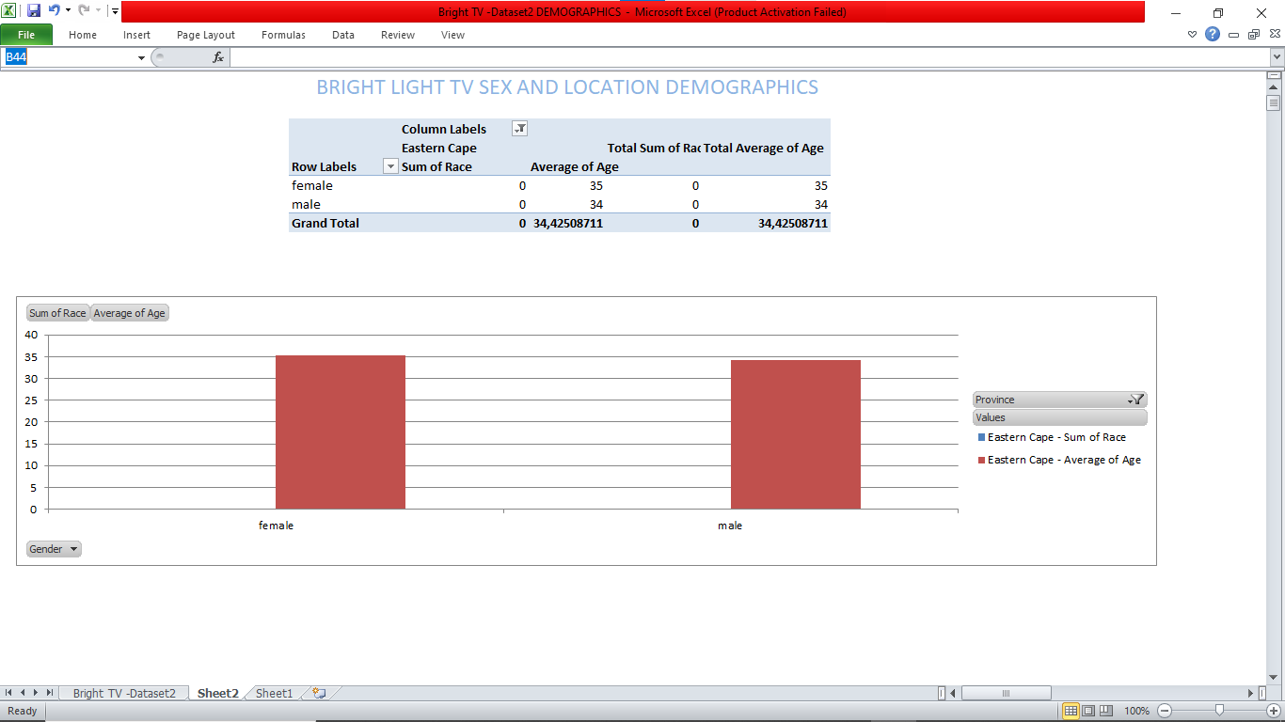

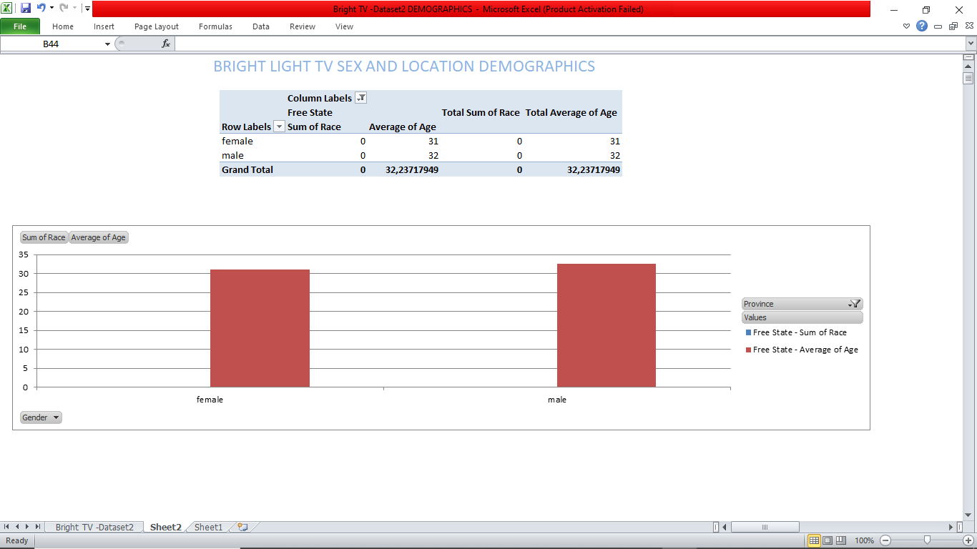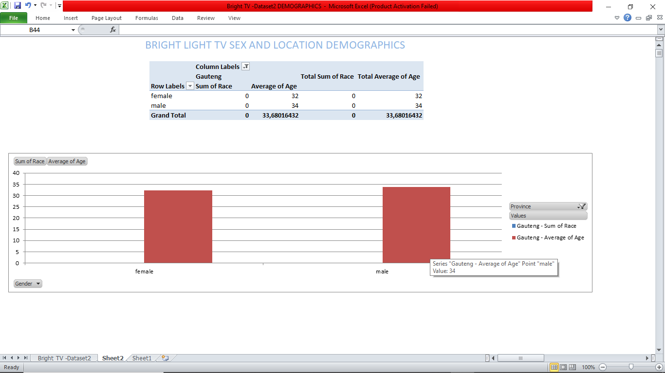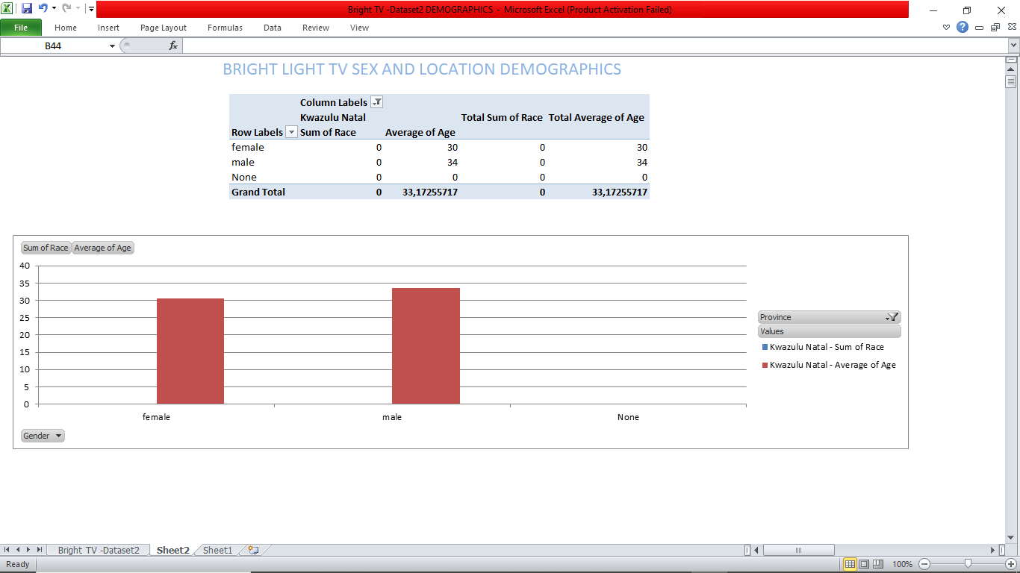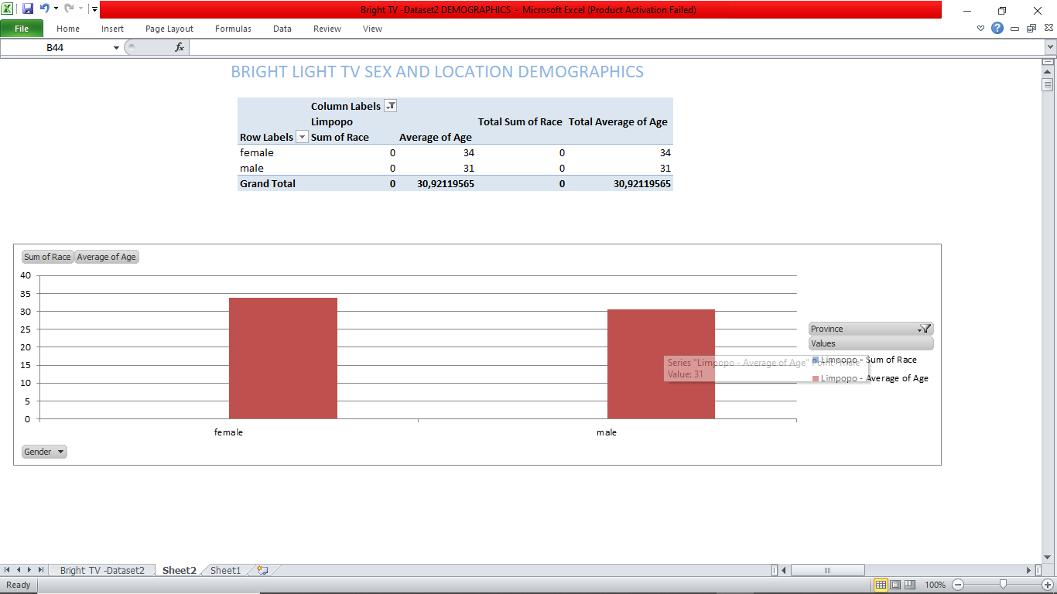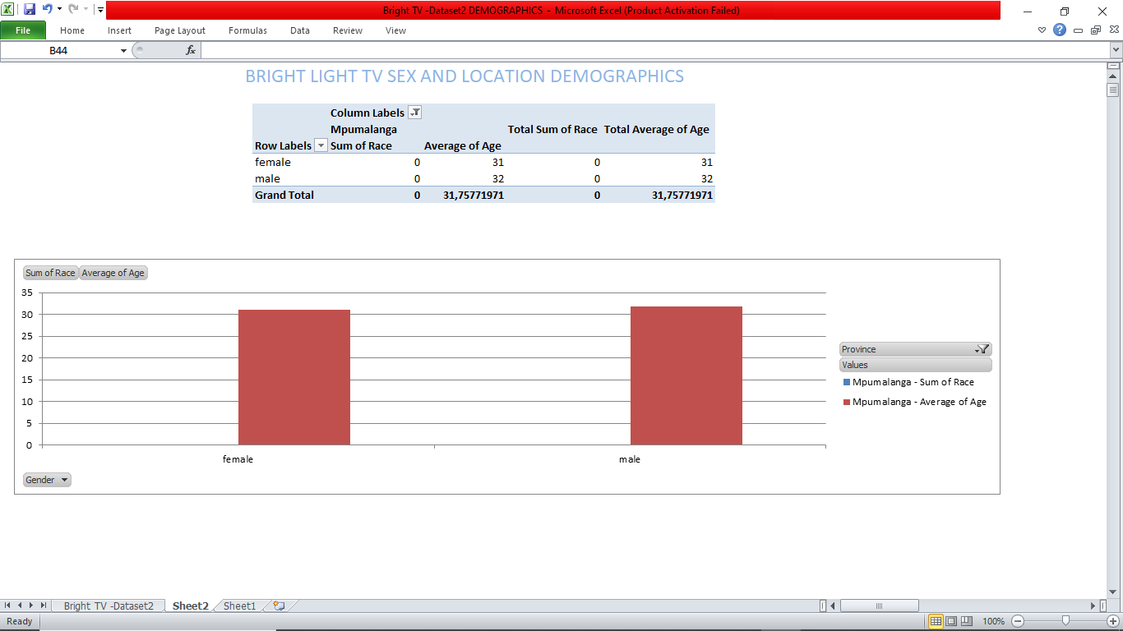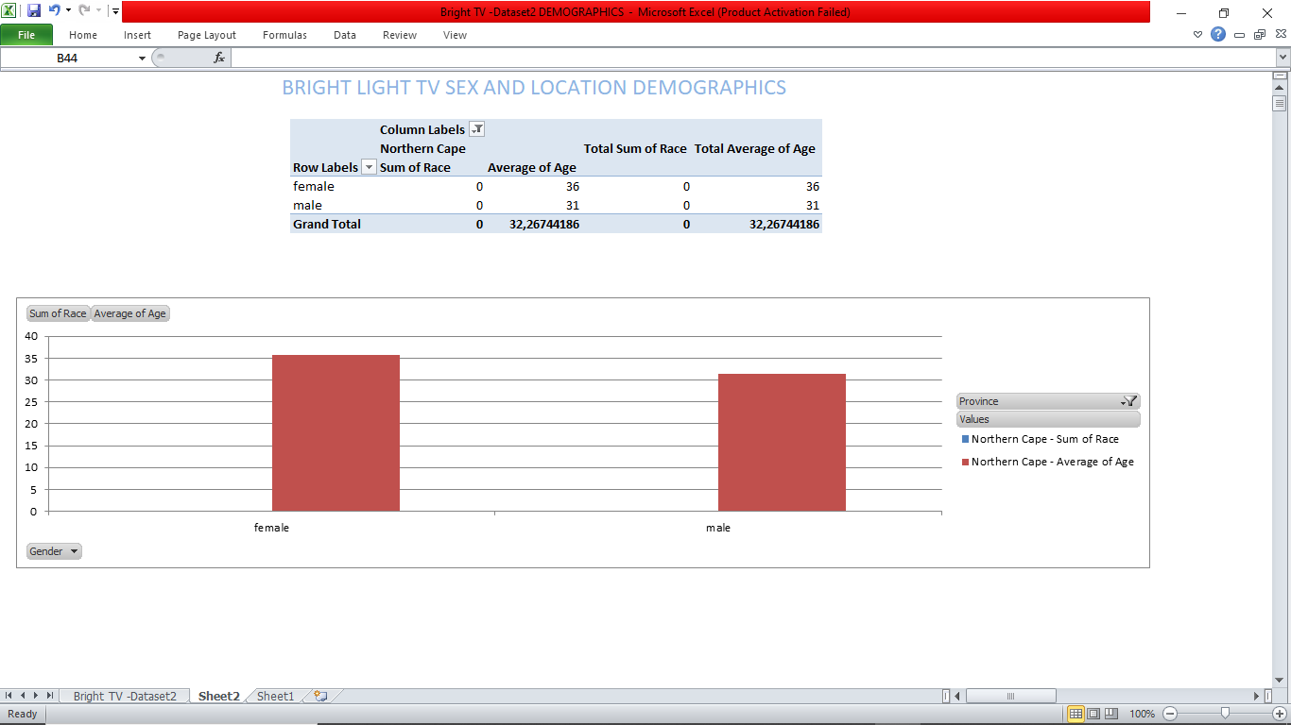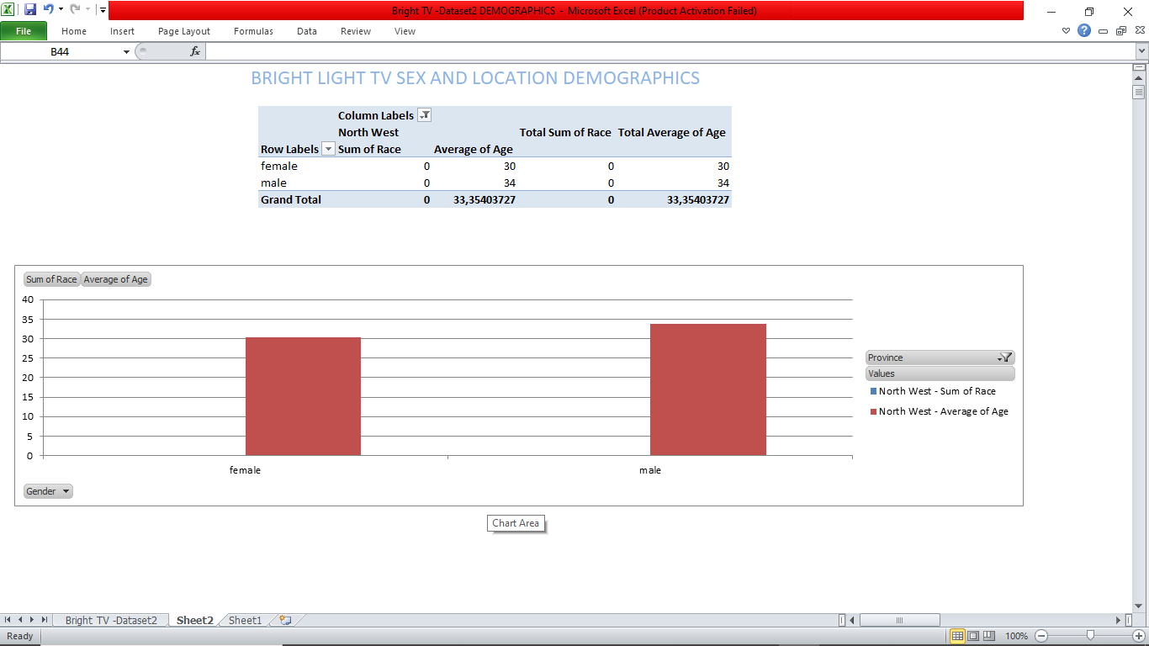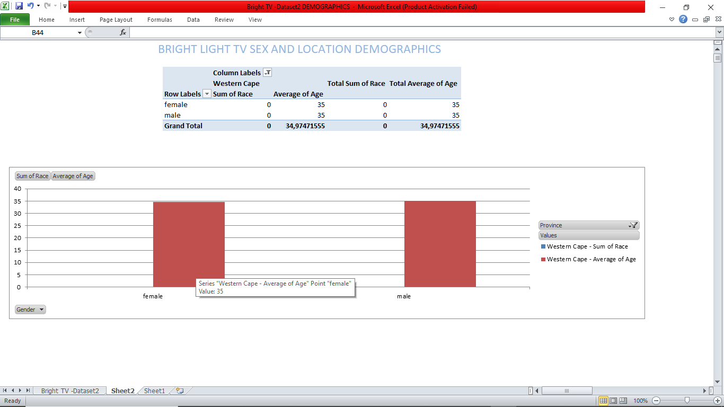

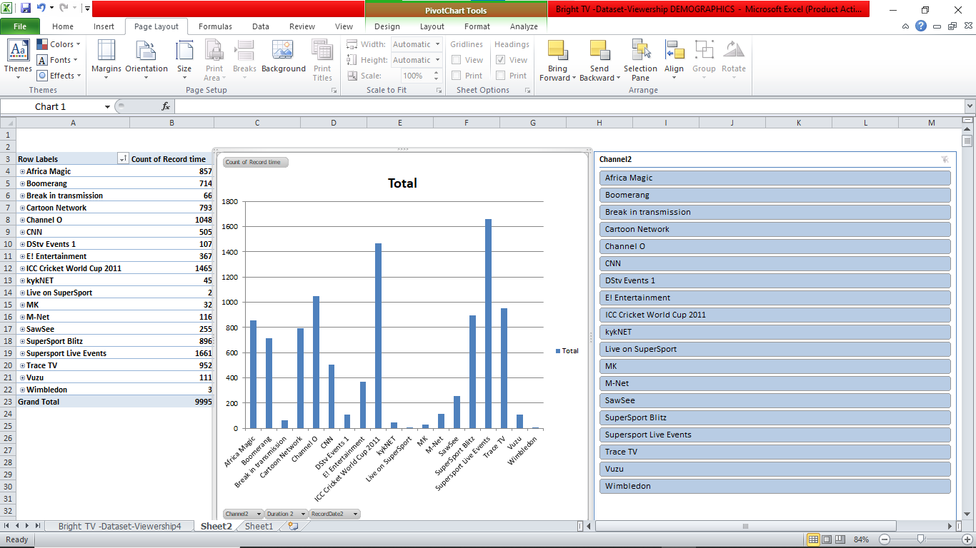

The above graph shows us the Channels and how many times they were frequently watch with the top 5 channels viewed being

* **Supersport Live Events**
* **ICC Cricket World Cup 2011**
* **Channel O**
* **Trace TV**
* **SuperSport Blitz**

The above list shows us that the viewers were of a younger demographic which lean towards watching live sporting events and highlights , music videos and concerts throughout the day and the 3 month period.

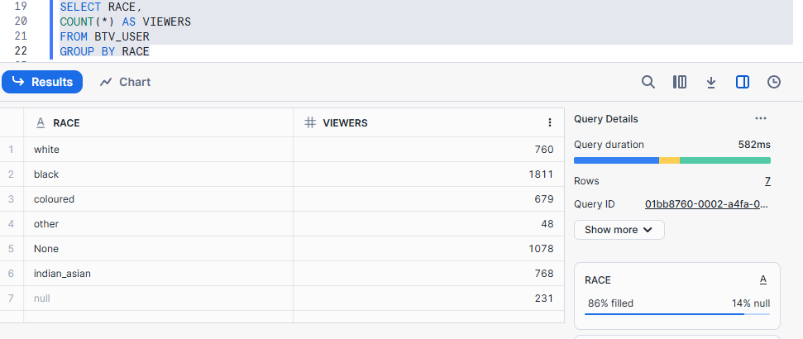

*Insights*

The above script shows us the different racial demographics that watch the various Channels.

Black/African viewers being the most viewers followed by Indian/Asian viewers, with ‘’Other’’ or non-binary people being the demographic with the last amount of views. This might be caused by a lack of programming that appeals to them and a lack of representation in the programming on offer.

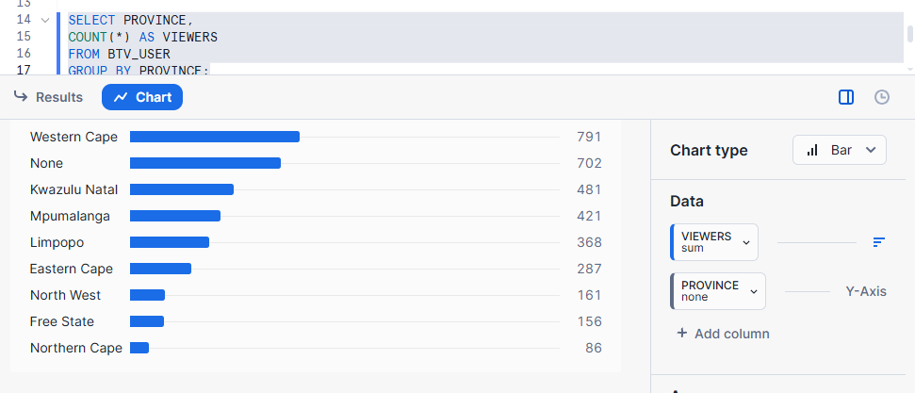

*Insights*

The above script show us the number of viewers in each province with the Western Cape having the largest amount of viewers and the Northern Cape having the smallest amount of viewers

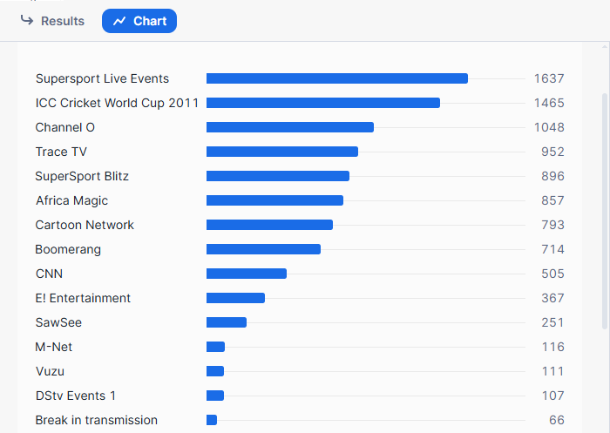

*Insight*s

The above SQL graph shows us the most popular channels during the 3 month period that was analysed

*General insights and Recommendations*

The factors that might influence consumption are as follows:

The first quarter of the year is a busy time for sporting events as it is usually the middle of most sports events seasons and the younger demographics are staunch supporters of their varies sports teams and often watch what their favourite teams do via the TV or the internet.

Programmes that could boost viewership on days that have low viewers is to simply cater to their audiences by firstly auditing who they are, where they’re from and what type of content best appeals to them. Music and Sports has shown us that it appeals to a large amount of people, content creators can shift their content towards what is already popular and most importantly stands the test of time rather then being a short lived trend.

Initiatives to grow BRIGHT TV user base would be to do more frequent data analysis of their users, stopping programmes like VUZU and DSTV EVENT 1 which unfortunately have poor viewership because of a lack of an identity and quality programmes.

*Thank you*